WEB DEVELOPMENT
ASSIGNMENT 2 Thraitha.k
2023001750
Task:
Create a basic HTML web page titled "My College Event" and apply CSS3 styling to enhance its appearance.
Assignment Points:
1. Apply inline, internal, and external CSS to different elements and observe how style precedence works.
2. Use basic CSS selectors (element, class, and ID) to style headings, paragraphs, and sections.
3. Style text using font properties and apply suitable text alignment for headings and content.
4. Create a list (ordered or unordered) and apply list and colour properties to improve readability.
5. Add a background colour or background image to one section of the page using C553.

1.css.html
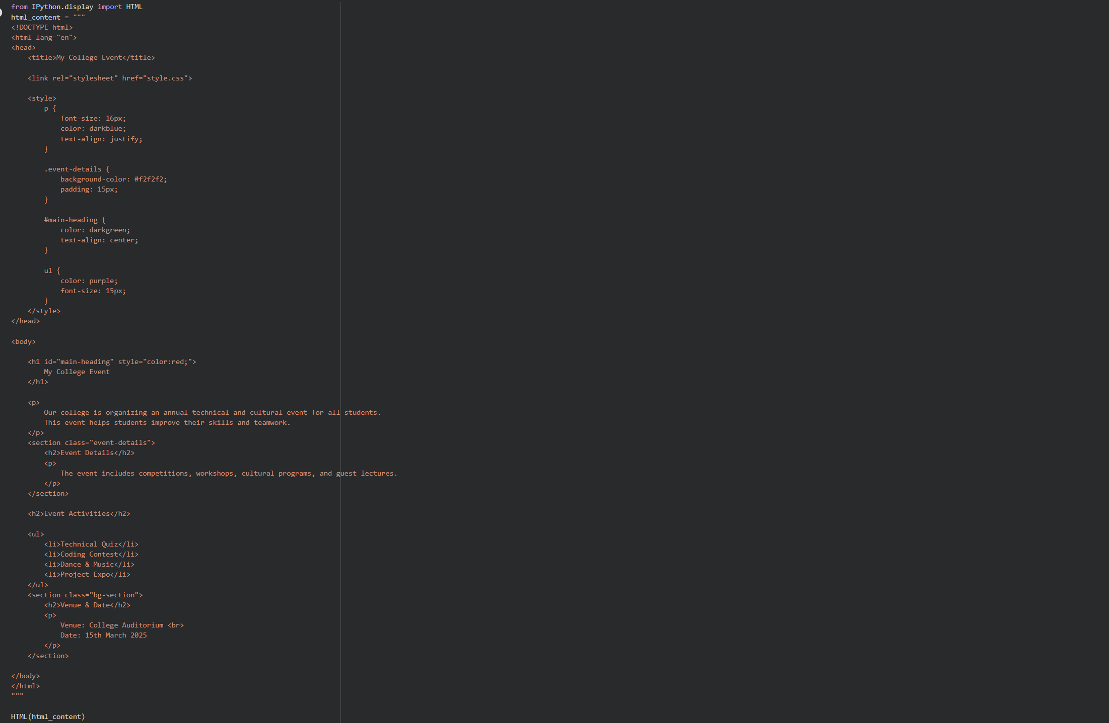
Output:

2.style.css
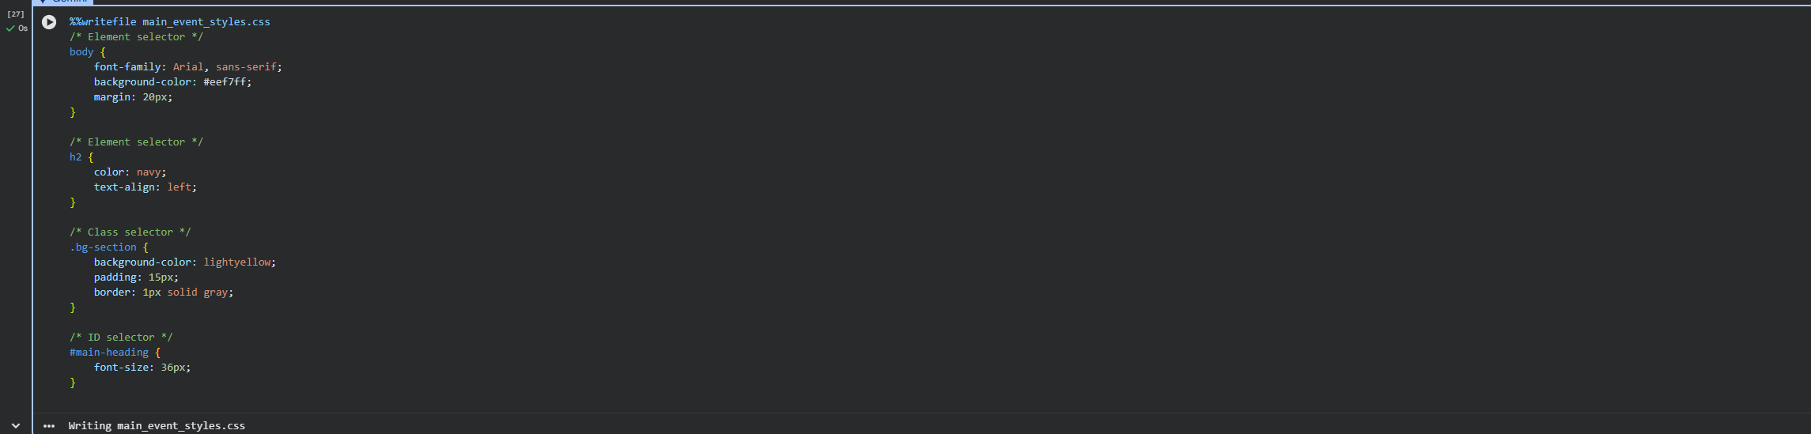
1. Inline, Internal, External CSS
- Inline:
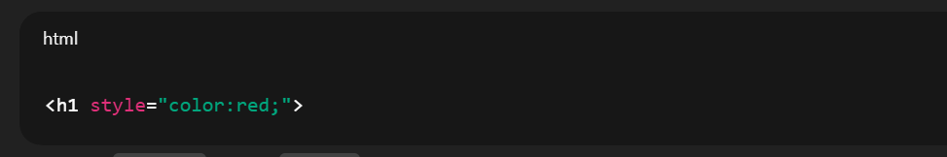
2. CSS Selectors Used:
Selector Type | Example
Element | p, h2, body
Class | .event-details, .bg-section
ID | #main-heading
3. Text Styling:
- font-family
- font-size
- color
- text-align
4. List Styling:
- Unordered list (<ul>)
- Text color & font size applied
5. Background Color:
